TGA Lesson Plan
Geography of the Indus Valley
Created by: Ashley Flood
Grade Level: 6 | Course Title: 6th Grade Social Studies
TN State Standard(s) | 6.23 Locate and describe the Himalayas and the major river systems, including Indus and Ganges and evaluate the importance of each.
Connection to CCSS | CCSS.ELA-LITERACY.RH.6-8.1  Cite specific textual evidence to support analysis of primary and secondary sources.
Time Required | One 45 minute class period  *students will need access to computers or teacher will need to print materials or use maps from student textbooks
Lesson Outline | Have students consider the following question (possibly as a Bell ringer): If you were going to start your own city from scratch, where would you put it and why? What would you be looking for in a location?  >Teacher may have students write an answer or simply participate in a group discussion.  Review with students the characteristics of civilizations previously discussed. Have students predict the following:  - What will the Indus Valley civilization have in common with previous civilizations we have discussed?  - What do you predict will be different about the Indus Valley civilization?  Students will participate in a web quest to further analyze the geography of India and what made it an ideal location for the beginnings of a civilization.  Have students log on to a computer and pass out the Student Handout (see below). Direct them to the following websites.  - Website #1 - Interactive Map of India: http://www.eduplace.com/kids/socsci/ca/books/bkf3/imaps/AC_07_215_india/AC_07_215_india.html  - Website #2 - Land of the Indus: http://www.bbc.co.uk/schools/primaryhistory/indus_valley/land_of_the_indus/

Student Handout

Using Website #1:
On the map, draw and label the Himalayan Mountain Range, the Indus River, and Ganges River:
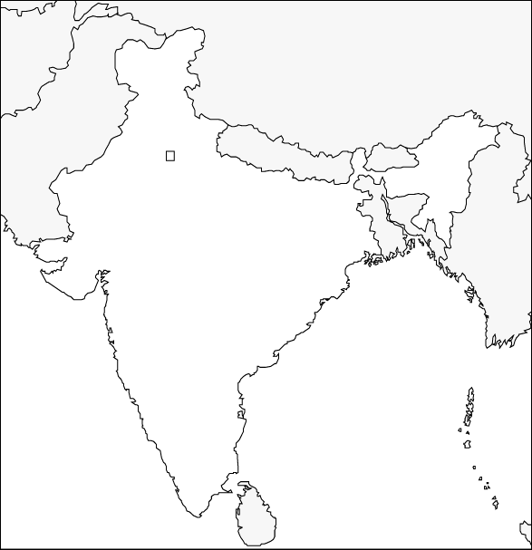

What resources are located near the Indus and Ganges rivers?
____________________________________________________________________________________________________________________________________________________________
Using Website #2:
What are the benefits of settling in a valley? Why not settle on a mountain?
__________________________________________________________________________________________________________________________________________________________________________________________________________________________________________
Why was it so important to settle near a river? What do rivers provide?

__________________________________________________________________________________________________________________________________________________________________________________________________________________________________________

