Population Campaigns By Lexi Krock
In 1952, India was the first country in the world to launch a mass media campaign to spread the concept of family planning in response to population growth. Most developing nations soon followed suit. While individual campaigns have had varying degrees of success, they have made a significant impact overall. According to a World Bank study, the average number of children per woman in the developing world declined by 2.5 children between 1960, when many of the campaigns began in earnest, and 1990, and it has continued to decline.
Efforts to promote family planning through print media, radio announcements, and television ads carefully designed for national audiences persist in most developing countries. Here, browse recent posters from population campaigns in China, India, and Kenya, and learn how their different approaches have fared in the decades since they began.

China: One Child
In this undated poster, China advertises its one-child policy as a means to a "prosperous life." Enlarge Photo credit: Courtesy of the Medical Materials Clearinghouse at the Johns Hopkins University Bloomberg School of Public Health/Center for Communication Programs
China's Communist Party first implemented the "one child" rule—perhaps the best-known population policy in the world—in the 1970s amidst growing concerns over whether the famine-prone country could continue to feed its skyrocketing population.
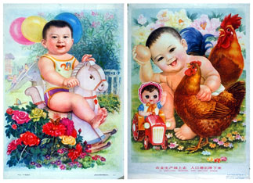
English translation: "Up agricultural production, down population increase"
The rule, which reportedly is more lax today, stipulates that urban couples should have only one child. Couples in rural areas, where 80 percent of the population lives, may have two or possibly more children but should delay getting married initially and then space their children.
Translation: "The party calls for the partisan to set an example of having only one child." Enlarge Photo credit: Courtesy of the Medical Materials Clearinghouse at the Johns Hopkins University Bloomberg School of Public Health/Center for Communication Programs
Families that violate the rule where it is most strictly enforced face mandatory abortions and severe financial penalties, while single-child couples throughout the country are entitled to better child care, preferential housing assignments, and cash bonuses.
The policy has generally worked, and fertility rates have fallen to an average of about two children per woman, down from more than five children per woman in the 1950s. However, the number of Chinese women having children today is still much greater than were having children in the previous generation, so China's population growth continues.
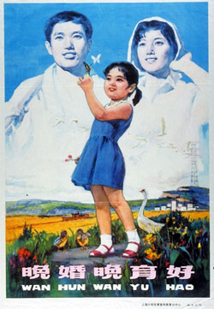
Translation: "It's better to marry and have children at a mature age." Enlarge Photo credit: Courtesy of the Medical Materials Clearinghouse at the Johns Hopkins University Bloomberg School of Public Health/Center for Communication Programs
National ad campaigns promoting "one child" link the policy to prosperity and good Communist citizenship. By showing happy single female children, many of the ads also seem to respond subtly to the traditional preference for boys, which some critics maintain has led to the killing of female infants.

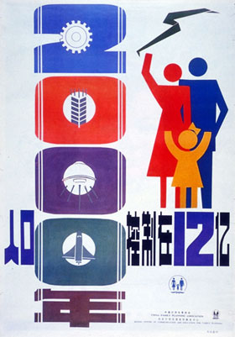
Translation: "Control our population at 1,200 million" Enlarge Photo credit: Courtesy of the Medical Materials Clearinghouse at the Johns Hopkins University Bloomberg School of Public Health/Center for Communication Programs

Population Campaigns By Lexi Krock
In 1952, India was the first country in the world to launch a mass media campaign to spread the concept of family planning in response to population growth. Most developing nations soon followed suit. While individual campaigns have had varying degrees of success, they have made a significant impact overall. According to a World Bank study, the average number of children per woman in the developing world declined by 2.5 children between 1960, when many of the campaigns began in earnest, and 1990, and it has continued to decline.
Efforts to promote family planning through print media, radio announcements, and television ads carefully designed for national audiences persist in most developing countries. Here, browse recent posters from population campaigns in China, India, and Kenya, and learn how their different approaches have fared in the decades since they began.

India: Changing Attitudes
India's population has more than doubled since its family-planning policy went into effect in the 1950s, and current projections predict that India will overtake China's position as most populous nation by 2050. However, India's total fertility rate has declined by more than 40 percent since the 1960s, and today the average number of children per woman is around three.
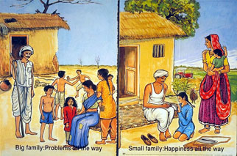
A 1992 poster from the India Ministry of Health and Family Welfare Enlarge Photo credit: Courtesy of the Medical Materials Clearinghouse at the Johns Hopkins University Bloomberg School of Public Health/Center for Communication Programs
The country's most recent approach to population issues focuses on the advancement of women economically, academically, and socially, as independent women are more likely to have small families. Indian public information campaigns are also working to counter favoritism for boys, a deeply ingrained tradition that drives couples to have more children.
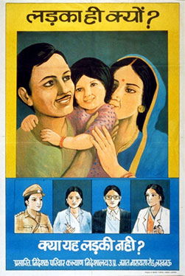
A 1993 poster from the India Directorate of Family Welfare. English translation: "Why only a boy? Are these not girls?" Enlarge Photo credit: Courtesy of the Medical Materials Clearinghouse at the Johns Hopkins University Bloomberg School of Public Health/Center for Communication Programs
Modern campaigns are a change from the darker days of India's population policy. In the 1970s, the government declared a population "state of emergency," began implementing forced sterilizations in the nation's poorest regions, and even rewarded medical workers who performed the most operations. The national focus on sterilization hindered women's acceptance of family planning, as many considered birth control an all-or-nothing proposition and chose to forgo it entirely.
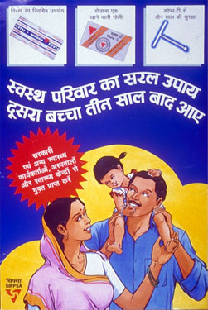
Translation: "For a healthy family, wait three years before your second child. You can get these family-planning methods from government health workers, hospitals, and health centers for free." Enlarge Photo credit: Courtesy of the Medical Materials Clearinghouse at the Johns Hopkins University Bloomberg School of Public Health/Center for Communication Programs
Today, India's population policy focuses on a number of issues, including advocating child spacing, informing women and men about the range and availability of contraceptive methods, promoting small family size, and presenting sterilization in a more humane light.

